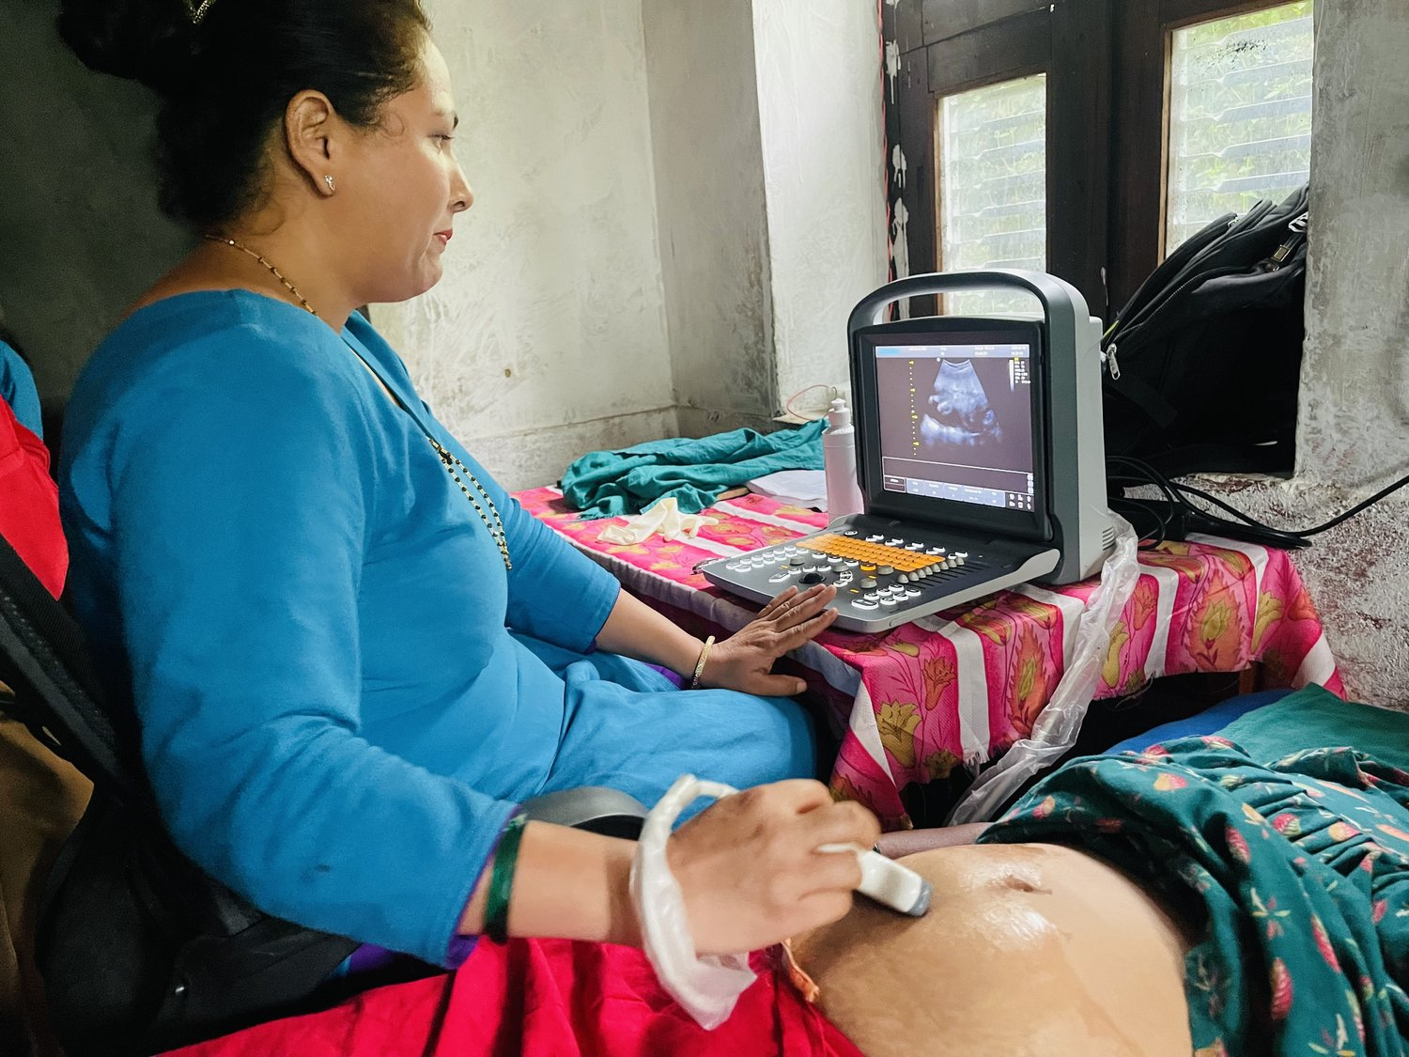


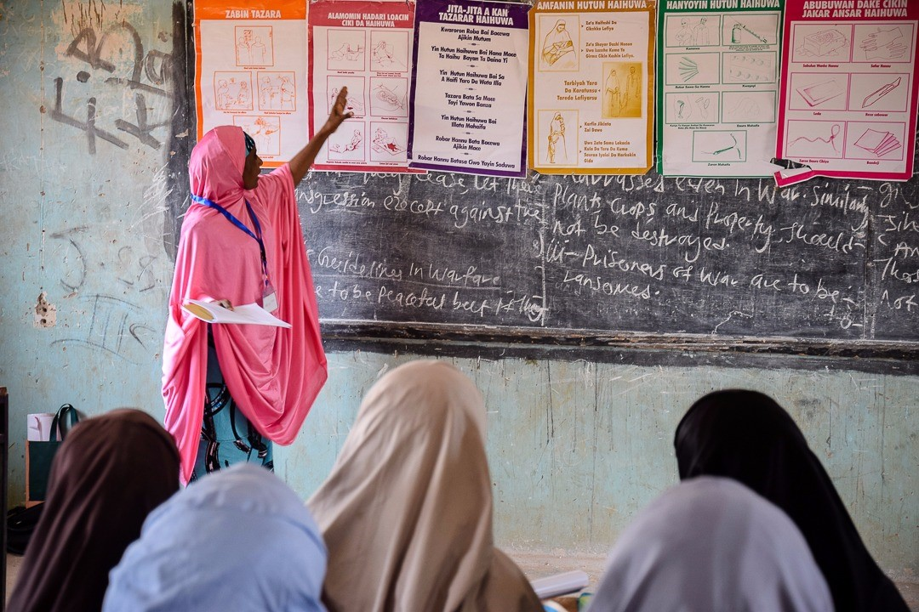


Project Profile

Maternal & Child Health (MCH)

Maternal & Child Health (MCH)

October 2025
Strictly Confidential

Strictly Confidential

Executive Summary
The Maternal & Child Health (MCH) Project represents a vital global initiative addressing one of the most urgent challenges of our time: improving maternal and child health outcomes in low-resource countries. The project provides life-saving interventions and strengthens healthcare capacity where it is most needed the most, operating across regions including Zambia, Uganda, Malawi, Ethiopia, Kenya, Tanzania, Papua New Guinea, Myanmar, Nepal, Vietnam, Laos, Philippines, Cambodia and Bangladesh.
This document outlines the project’s goals and funding requirements of $10,000 AUD, to expand training, provide essential equipment and ensure sustainable maternal and child health programs across these countries. Further donor support will allow the project to extend its reach and deepen its impact.
MCH is a Rotary Australia World Community Service (RAWCS) project. MCH is not just a medical issue, it is a matter of dignity, equality and survival. Donor support can save lives, empower women and transform communities, ensuring a healthier and more hopeful future for mothers and children worldwide.

Rotary Australia World Community Service (RAWCS)

About Us
Founded in 1966, RAWCS delivers Rotary’s humanitarian, development and disaster relief projects both in Australia and internationally. Over the years, we have contributed $0.5 billion in aid and completed thousands of projects, benefiting hundreds of thousands of people across 45 countries. At RAWCS, we are committed to fostering diversity, equity, and inclusion to achieve our goal of making a positive impact on communities in need, both in Australia and developing countries. Upholding human rights principles is fundamental to all aspects of our operations.

Mission
RAWCS' mission is to facilitate Rotary clubs in Australia to deliver humanitarian aid projects that support disadvantaged communities and individuals both in Australia and internationally, focusing on areas like disease prevention, clean water access, health, education, sustainable economic growth, environmental conservation, and the promotion of peace and understanding. The organization provides the framework, infrastructure, and support for these projects, ensuring accountability and fostering lasting positive impact.
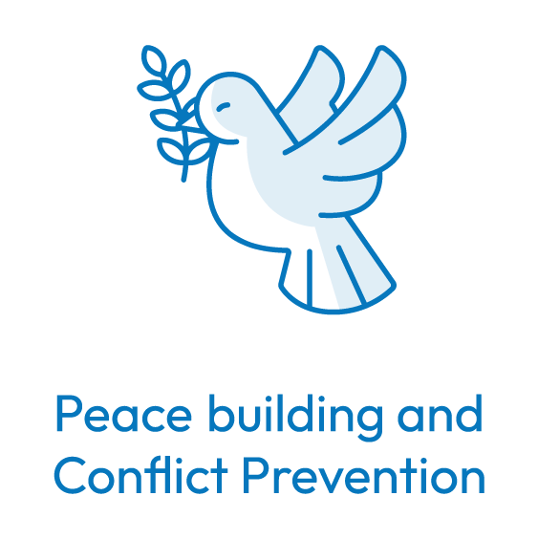
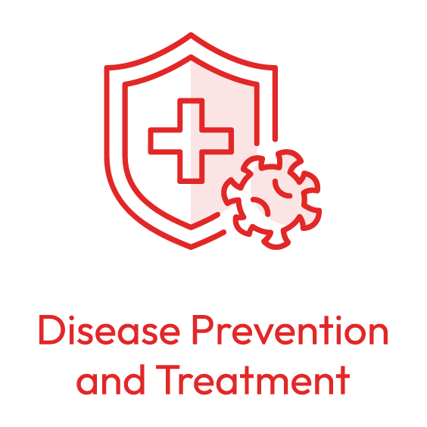
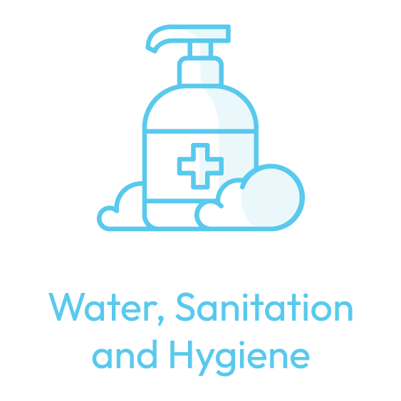
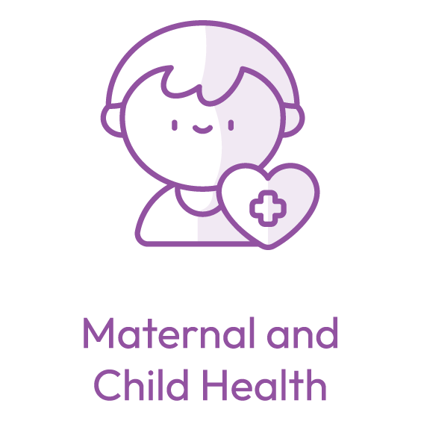
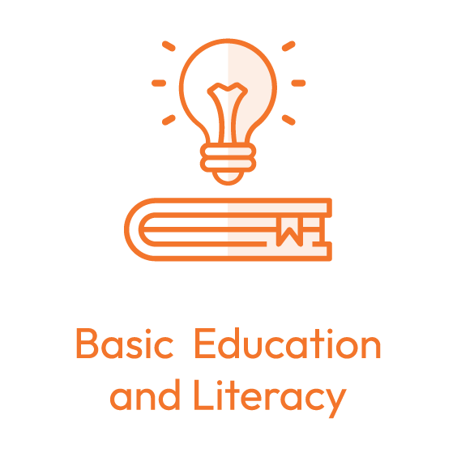
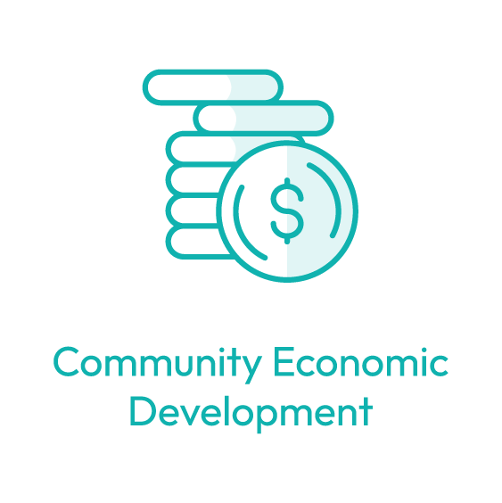


Vision
To make a positive and lasting impact on communities in need, both in Australia and developing countries overseas.

Our Value Proposition
- Rotary brand: we are part of Rotary’s highly recognised global brand.
- History: We have a long track record of successfully delivering thousands of projects.
- Large network of Rotary volunteers: We have the strength of global network of Rotarians and Rotary clubs to implement projects and engage with communities overseas and in Australia.
- Diversity of causes: We support most of the 17 Sustainable Development Goals (SDGs). As such, there aren’t many humanitarian or disaster relief projects that we don’t deliver.
- Agility: We have the capability to rapidly stand-up a project to assist victims of disaster or tragedy.
- Complete ecosystem: our support services include systems and processes to raise and manage funds, undertake projects, mobilise volunteers and provide regulatory compliance through strong governance and quality assurance.





- Low Admin Fees and Tax deductibility: We have the lowest admin fees in the NFP sector, offer tax deductibility and have put in place both DGR 1 and DGR 2 facilities.
Ecosystem
History
Low Fees
Volunteers
Agility
Causes
Brand
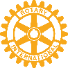


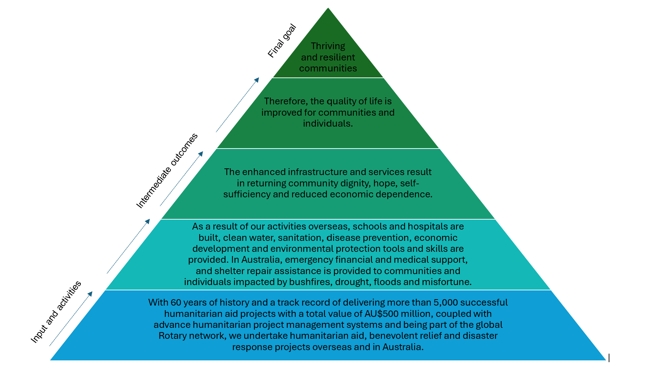
Our Theory of Change

The Project: Maternal & Child Health (MCH)

The Need
MCH outcomes remain a significant challenge in many low-resource countries, where access to quality healthcare is limited and maternal and infant mortality rates remain high. Communities in countries such as Zambia, Uganda, Malawi, Ethiopia, Kenya, Tanzania, Papua New Guinea, Myanmar, Nepal, Vietnam, Laos, Philippines, Cambodia and Bangladesh face systemic barriers including limited healthcare infrastructure, a shortage of trained health workers and lack of access to family planning.
Globally, approximately 260,000 women die each year from pregnancy and childbirth-related causes — that’s one woman every two minutes — with over 90% of these deaths occurring in low- and lower-middle-income countries. Maternal mortality ratios in low-income countries average 346 deaths per 100,000 live births, compared to just 10 deaths per 100,000 in high-income settings. While maternal mortality has fallen by around 40% since 2000, progress has slowed significantly since 2016. Sub-Saharan Africa still accounts for 70% of maternal deaths and Southern Asia contributes a further 17%. Without urgent intervention, mothers and children remain at risk of preventable deaths and long-term health issues.

The Solution
Funding targeted health initiatives that strengthen healthcare capacity, expand access to services and deliver life-saving interventions. The program includes training midwives in obstetric ultrasound in Malawi, supporting family planning programs in Papua New Guinea and providing prolapse surgeries for women in Uganda. Our approach is innovative in its focus on local partnerships, community-driven solutions and sustainability.

Impact and Outcomes
This project has already delivered measurable results across multiple countries. In Malawi, midwives are trained in ultrasound techniques, improving early detection of complications. In Papua New Guinea, family planning and contraceptive programs empower women to manage reproductive health safely. In Uganda, marginalized women are accessing prolapse surgeries, restoring dignity and health. Collectively, these efforts strengthen maternal care, improve reproductive health and enhance community wellbeing. With donor support, thousands more women and children will gain access to essential healthcare services.

Funding Requirements
The project’s immediate donation goal of $10,000 AUD will aid in family planning in East Africa by procuring Long Acting Reversible Contraceptives (implants) for not-for-profit health organisations and clinics serving vulnerable and disadvantaged communities. With global funding for family planning declining in many resource-constrained countries, contributions this year are especially impactful in ensuring women can access essential healthcare and plan for safer, healthier futures.

How You Can Help
Your support can save lives and transform futures. Donors can contribute through one-time gifts, recurring donations, or major philanthropic commitments. Beyond financial contributions, donors can engage by advocating for maternal health, raising awareness and partnering in program delivery. Every contribution, regardless of size, helps ensure mothers and children receive the care they need.

Recognition and Stewardship
Donors will be acknowledged through Rotary’s recognition channels, regular updates and impact reports. Opportunities exist for naming rights, public acknowledgment, or private briefings on program progress. Transparency and appreciation remain core values, ensuring every donor feels connected to the outcomes they enable.

Governance and Accountability
The project is managed under RAWCS with oversight from Rotary clubs and strict governance processes. Funds are safeguarded through regular audits, 6-monthly partner reports, and transparent evaluation. RAWCS is fully registered with ACNC, ACFID, ATO, ASIC, and DFAT, ensuring compliance with Australia’s highest standards of governance and accountability.

Donation Link
https://directory.rawcs.com.au/17-2014-15

Contact Details
Project number: | 17 of 2014-15
Manager: | Rtn Marnie Rickards  (M) 0417 431 054  Email: marnie@dak.org.au
Deputy manager: | PP Sue Huntley  (M) 0437 345 041  Email: sue.backupwhenneeded@gmail.com

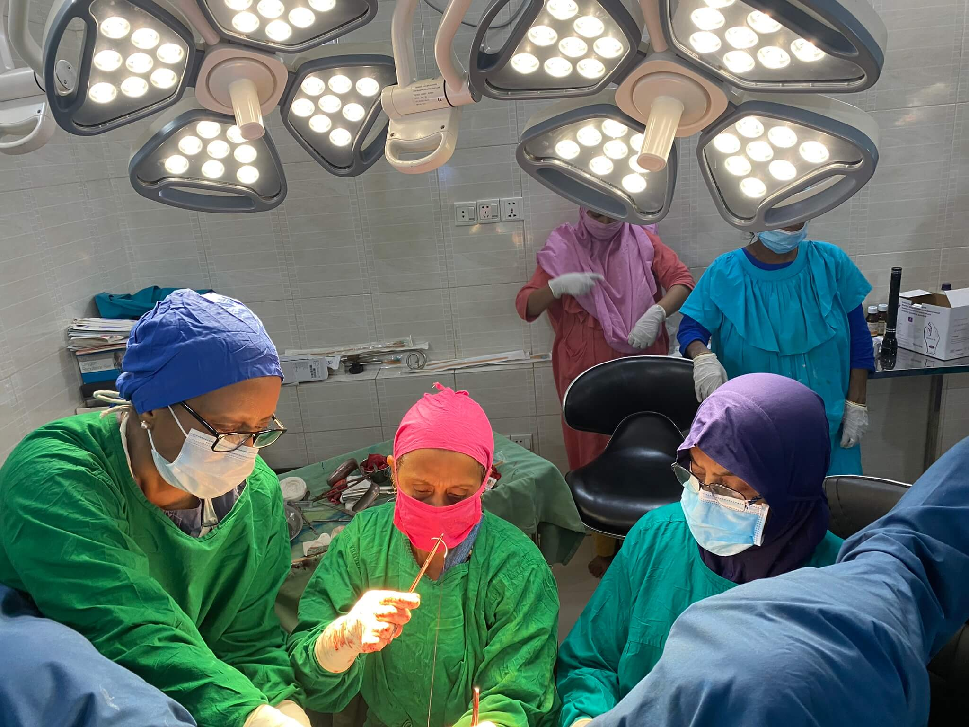
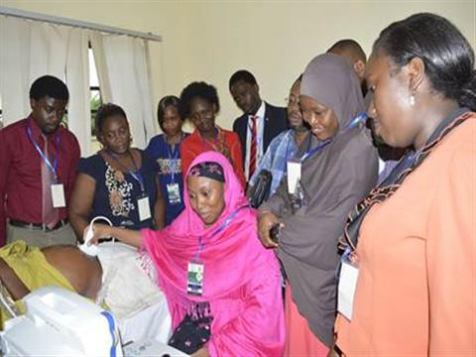
Annex

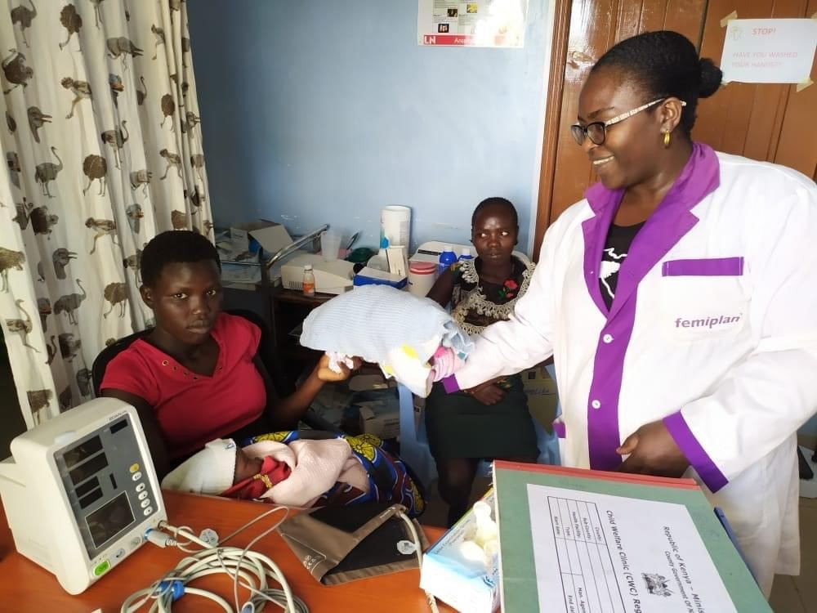
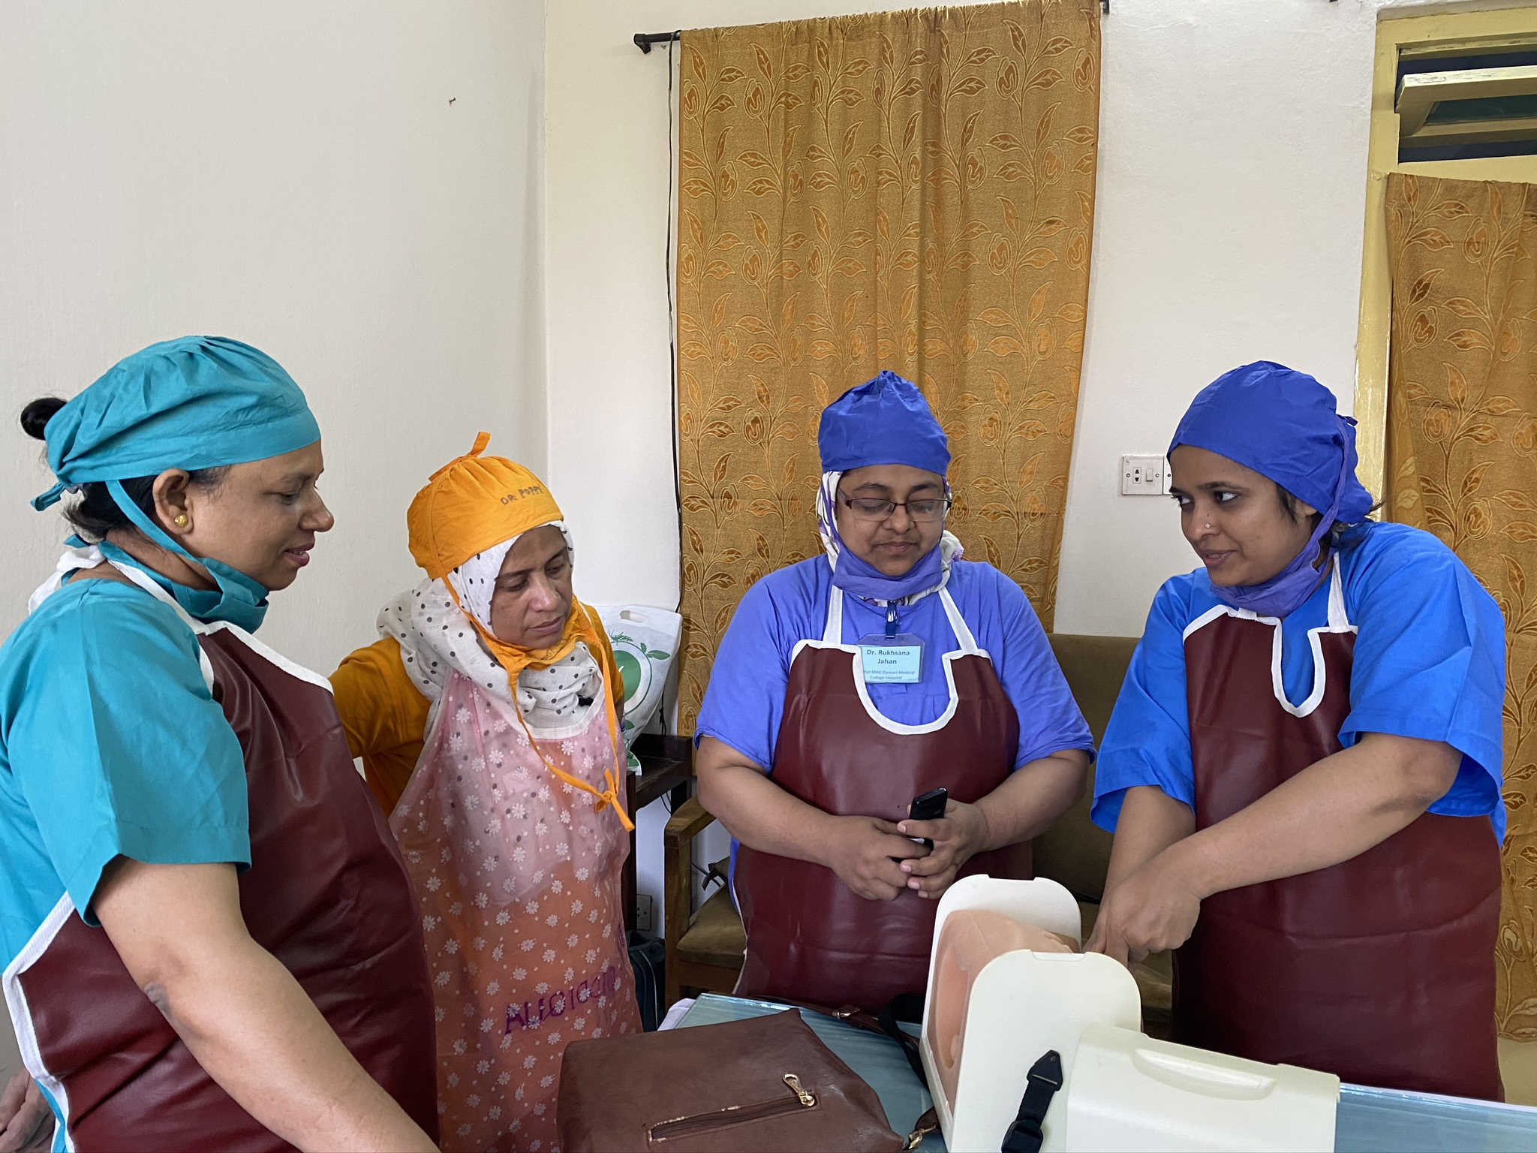

https://www.who.int/news-room/fact-sheets/detail/maternal-mortality?
https://www.who.int/news-room/fact-sheets/detail/maternal-mortality?
https://data.unicef.org/topic/maternal-health/maternal-mortality/?
https://www.who.int/news-room/fact-sheets/detail/maternal-mortality?

